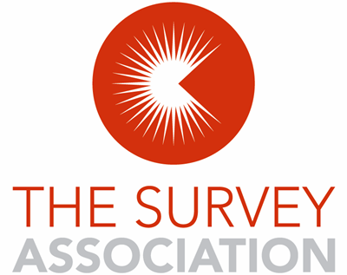

**Introduction to Surveying**

**An activity pack for Scouts**

The practical and problem-solving skills developed by 10–14-year-olds in Scouts are excellent foundations that can be built upon by partnering with a local group and encouraging the young people to explore a career in surveying.

This activity pack is a rough guide to running a session with your local Scout group.

Discuss with the Scout Leader how your session can benefit the young people. They will even be able to tick off some of the requirements to achieve the badges below:

* Navigator
* Geocaching
* Teamwork

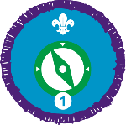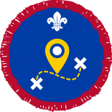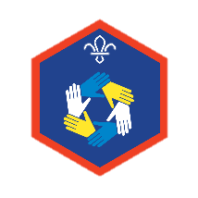

**Presentation­**

If you have access to a presentation screen, we have a template of a presentation you can modify and share with the young people. It is a good starting point to get them interested and give a brief overview of what you do.

Here are some talking points to begin with:­

* Land surveying/Geomatics –What words might they have heard of already?
* What is Surveying?
* Video from CICES – This is a great tool and sums up what surveying is in an easy-to-follow video for the young people.
* History – Where does it come from, How did surveying used to work?
* What is GPS/GNSS?
* STEAM – Do they already learn about some of it in school?
* Jobs in Surveying?
* Examples of projects you have worked on?



**Chainage and**

**Offset** **Survey**

**Objectives**

1. Introduce the concept of surveying by creating accurate location diagrams from an offset in chain survey.

2. Working in groups they will learn how to use an optical square to make their observations.

3. Learn the importance of collecting accurate measurements as well as how to communicate these well with their group.

**Time needed**

**30 minutes**

**Materials**

* **Optical Square (per group)**
* **Tape Measure (per group)**
* **Roll of Tape/Rope**
* **30x30 grid paper (attached)**
* **Sharpened Pencil**
* **Objects to measure (these could**

**be existing such as a tree or a bench**

**or objects you place such as a ball or a hat)**

**You will need a large area for this activity so works well if you have access to an outside space, if not the Scout hut or hall should work just as well.**

**Instructions**

**1**

Divide the section into appropriately sized groups with their equipment. Explain the importance of accurately locating and recording data as a surveyor and why it is necessary to position objects that lie in the vicinity of the main survey line. Here you can demonstrate how an optical square allows surveyors to do this.

**2**

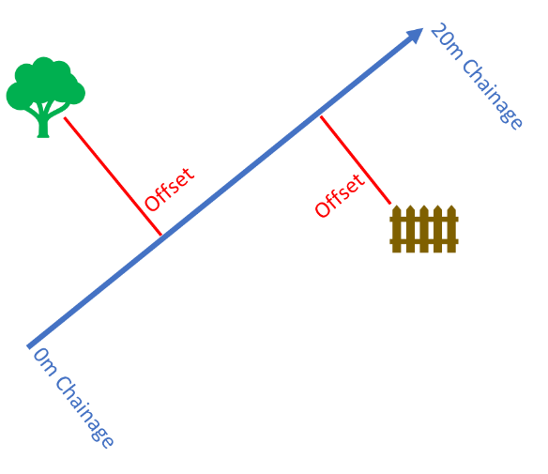Lay 20m of tape on the ground, creating your vertical chainage line. If you are in an outside space, you can use trees and fences as the objects to offset to – make it clear to the children what they are measuring to. If you are inside lay out objects on the ground to offset to like a football or bucket for example.

**3**

In their groups ask the children to walk their way up the chainage line using their optical square until they reach the offset objects beside them.

**4**

The other members of their team now need to measure the distance along the chainage they are standing and the distance offset of the object. This then needs to be replicated on their grid squares, in order to draw a diagram of the survey site.

**Allow the young people to switch roles within their groups so they each get a go at measuring – reiterate the importance of communicating in their groups.**



**Time needed**

**10 minutes**

**Materials**

* **Mobile Phone with the What3words app downloaded**
* **Tape Measure (per group)**
* **Roll of Tape/Rope**
* **30x30 grid paper (attached)**
* **Sharpened Pencil**
* **Objects to measure (these could**

**be existing such as a tree or a bench**

**or objects you place such as a ball or a hat)**

**What3words**

**Objectives**

1. Understand how surveyors use GNSS in their day-to-day life and how the young people might use it in theirs.
2. Use What3words to locate the objects in their survey site in order to compare different methods of surveying.

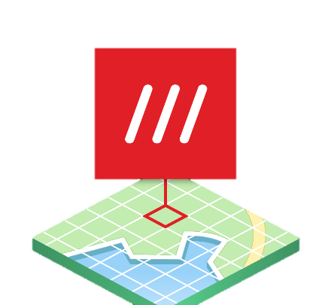 **Instructions**

**1**

Firstly, ask the young people to measure out a 3x3 grid with rope/tape just by eye. This should be easier for them after they have completed the chainage and offset activity. Now get them to measure their square with a tape measure to see how accurate they were. They can now use what3words to find the location of their square.

**2**

Once they understand the concept of how GPS works, get them to go back and measure the objects from the chainage and offset activity using what3words and record it on their diagram.

**3**

**Once the young people have understood the basic concept of surveying, it is a good time to introduce other ways of collecting the data. Briefly explain how GNSS works and how it is used in surveying.**

**Ask the young people how they use GNSS in their lives?**

**Explain how the What3words app works by dividing the world into 3m squares with a unique 3-word address using GNSS.**

Compare the results between groups to see if they got the same words. If they differ you can ask them why this is? How could they make it more accurate? (1mx1m grid).

**4**

Ask them to look at their house on what3words and see if their toilet has a different3 word address to their shower for example! Bring the discussion back to surveying and how you use this in your day-to-day life.

**Take it Further!**

Here are some more resources and ideas you can use to plan your session.

* Get Kids into Surveying have some amazing resources and worksheets – you could share this with the leader, and they could do some follow up activities after your session. https://www.getkidsintosurvey.com/
* Do you have any equipment you can bring in and show the young people?

