TSA scout activities step by step guide
As you know, we are on a mission to ensure that ‘every young person knows about surveying as a career’! Representatives from Storm Geomatics have taken this vision and developed an excellent initiative to engage with local scout groups and introduce them to our world of surveying.
We believe that scouting and surveying share numerous similarities – the fundamental scouting skills of teamwork, problem solving and a love for the outdoors are highly transferable to a career in surveying. Most scout groups will welcome visitors to offer a session to their group and the surveying activities will tie into various badges that the scouts could be working towards.
Don’t worry about being with young people if you are not used to this – we can help with guidance on what to do and how to talk to young people. Also, don’t worry about being alone with young people and safeguarding issues – there will be a scout leader or helper with you at all times, so there is no need for DBS checks etc. You may have colleagues who have been in to talk to young people before who can share some advice on how best to go about it.
Steps:
- Identify your local scout (or other) group – if you have a contact through a leader, helper or parent you can contact them direct, or we have a list of groups in different areas
- Contact them with an introductory email – example provided that can be adapted
- Look at the activity suggestions already available and feel free to adapt these, or develop your own to suit your area of expertise – we have activities and sheets outlining how to use them, and these are being added to all the time as more organisations go into groups
- Go and lead a session with the group – this will probably be for an hour or two, and leaders will be with the young people, so you won’t need to get involved with crowd control, but can carry out the activities and inspire the next generation of surveyors.
- This is obviously a long game and it will be some years before any of these young people might become surveyors, but we’re hoping to spread the awareness and spark an interest in some of the young people we interact with.
- Please let us know when you go into groups, so we can keep track of all the interactions.

Once you have been in, please:
- Pass on any activities that you have used, so they can be shared with others and adapted further if required
- Share any photos and comments that you receive, and ideally a write up of the session, so we can use these for promoting the scheme and let people know what our members are doing

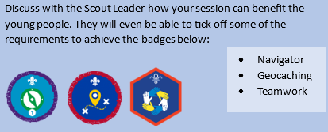
Relevant badges:
- Navigator
- Geocaching
- Teamwork Challenge Award

